Ashish Bahuguna : Ashish is one of the Co-founders of Bitscape and serves as the Global Technology Head. Ashish is a two decade veteran in IT Consulting. A Solutions-oriented System Architect, Ashish has notable success directing a broad range of IT initiatives while participating in planning and implementation of multiple complex projects. Always accepting challenges which utilize his technical skills effectively, Ashish has demonstrated a track record leading successful projects and coordinating with user departments in system design, testing, and efficiency. Read more on bitscpe here : <http://www.fb.com/Bitscape.Infotech.Pvt.Ltd>

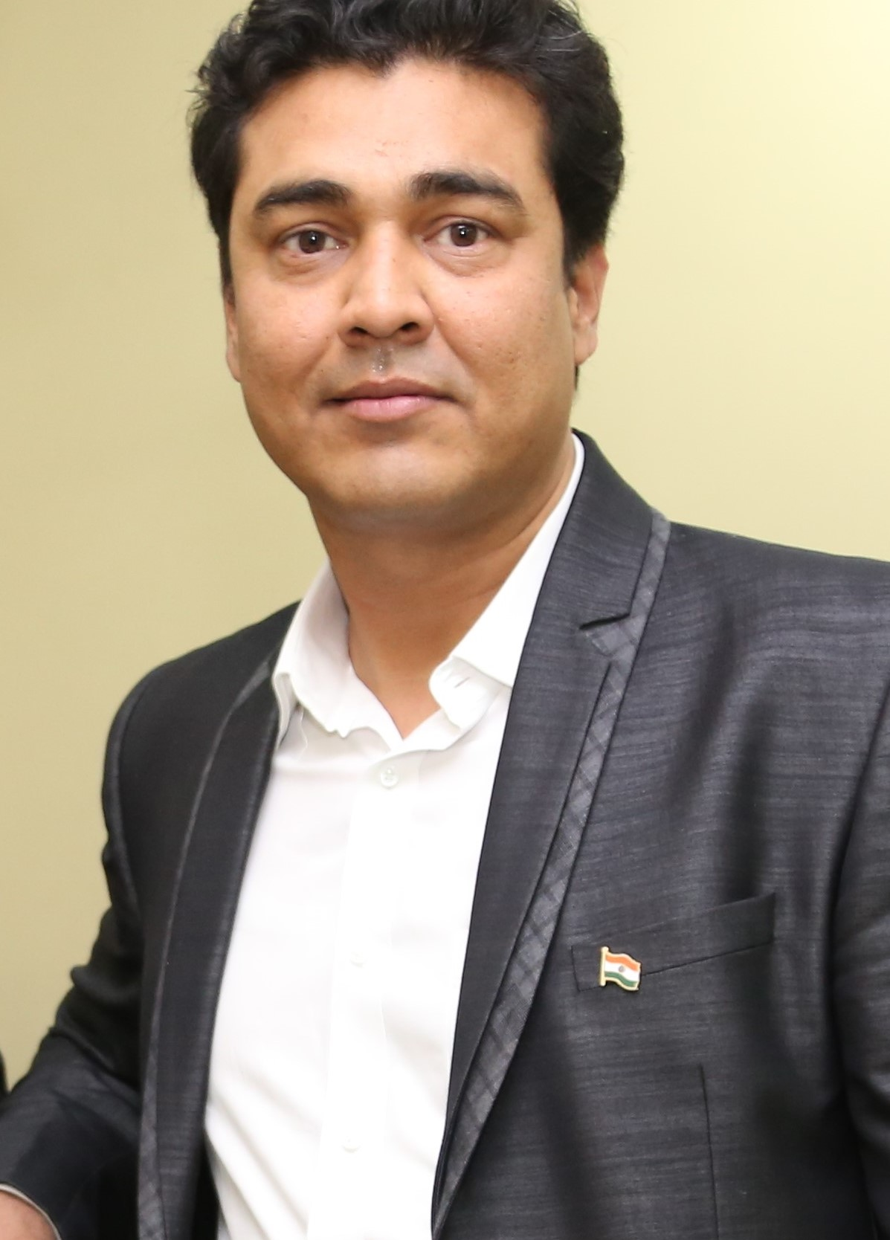

Asjad Lakhani: Asjad, a Sr. Solution Consultant and Project Manager at Bitscape has 9+ years of Microsoft Technology Experience with core expertise on business productivity and workflows. He has a MCTS for SharePoint, Microsoft Project and Microsoft BI. Asjad is also p-seller in Microsoft India program assisting Microsoft teams in solutions sales in western part of India.

